**Bug description**

DiceTest.class [file name] tried to call roll method to test class Dice. All six symbols were output expected of the testing, however, the actual results showed that "SPADE" value cannot be obtained. A bug named Bug 6 is found. Below are screenshots of the actual results and the source code error.

Figure 1: First test result [DIAMOND]

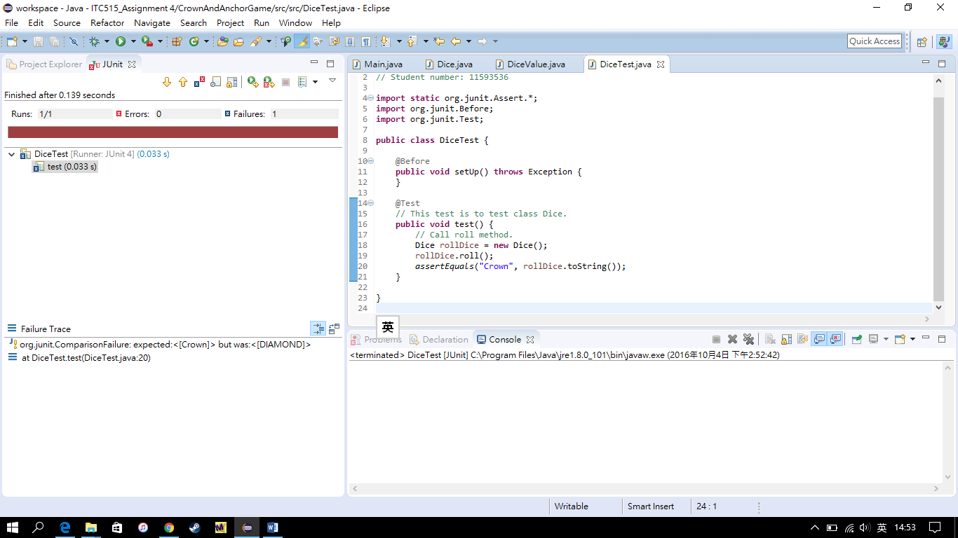

Figure 2: Second test result [HEART]

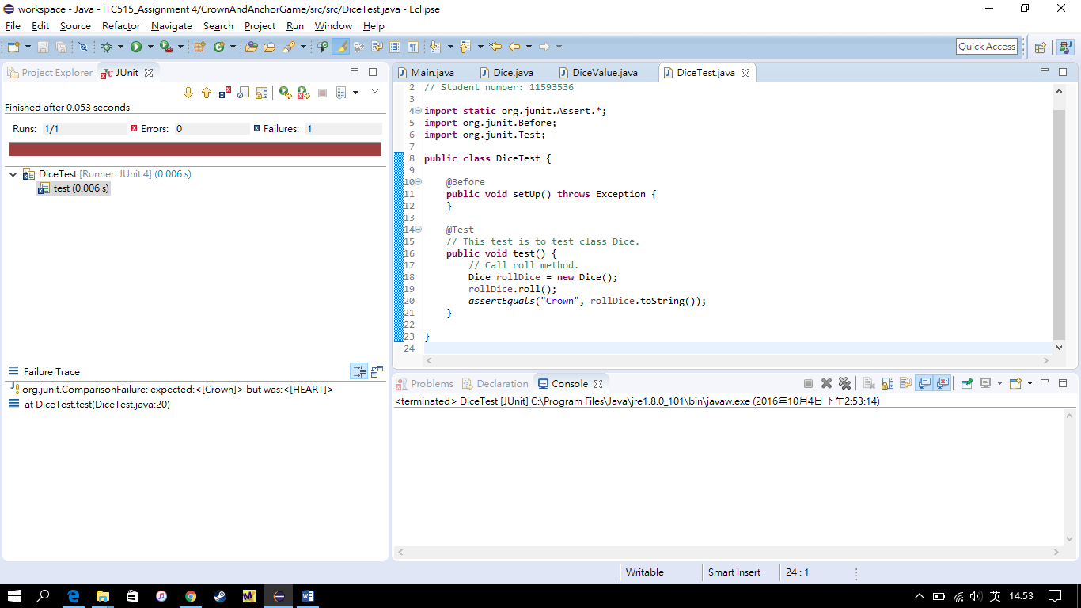

Figure 3: Third test result [ANCHOR]

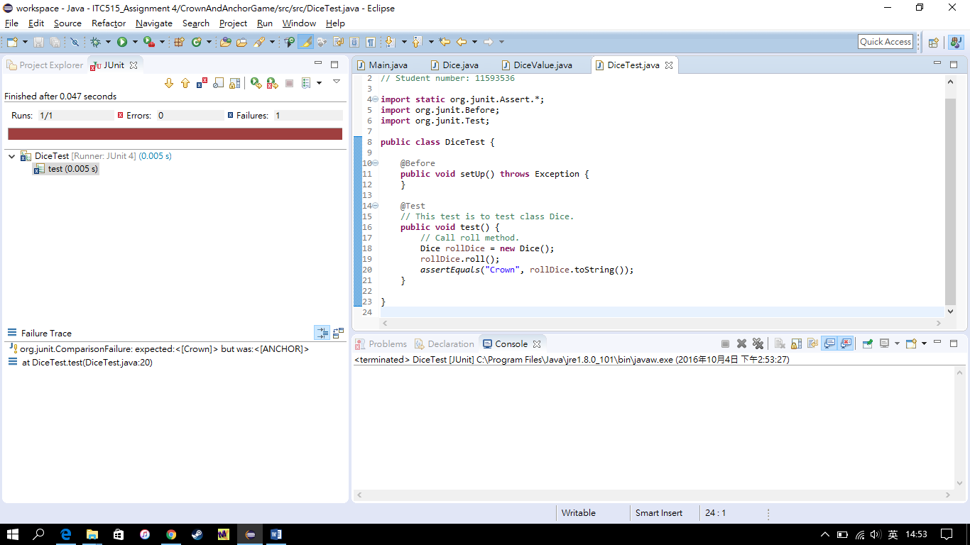

Figure 4: Fourth test result [CROWN]

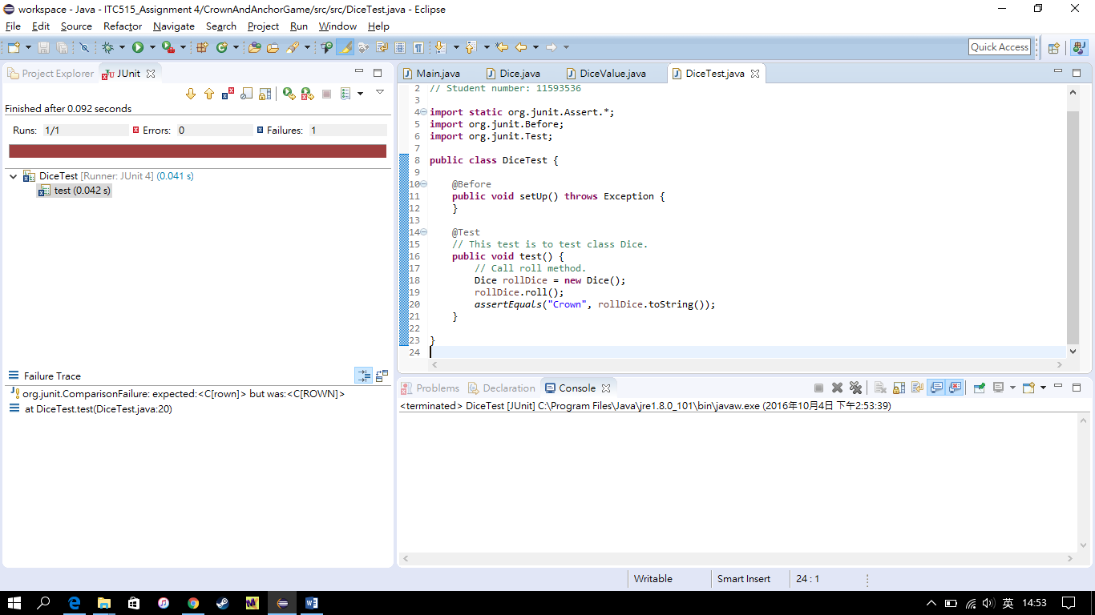

Figure 5: Fifth test result [CLUB]

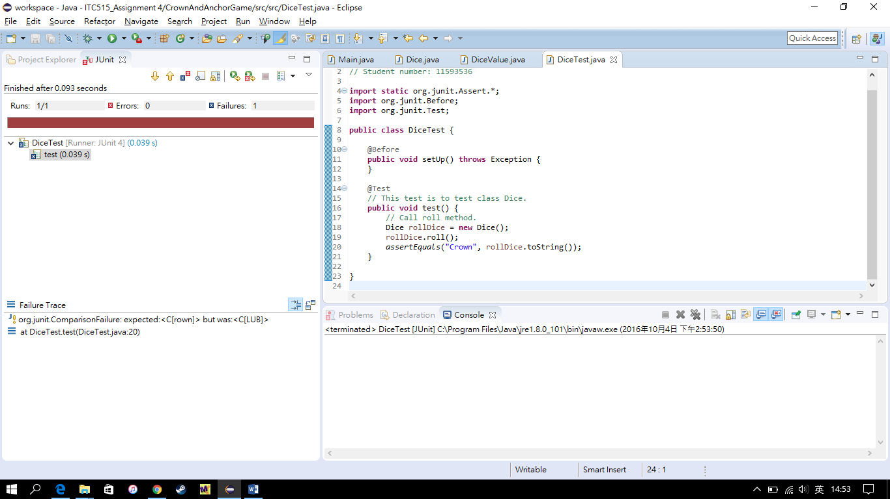

Figure 6: Source code error

